Table of Contents
Summer Vacation 6
By: Abril G. 6
When My Baby Brother Was Born 7
By: Alondra P. 7
Football 8
By: Amare S. 8
The Robbery 1973 8
By: Andrew Ma. 8
My Wallet 9
By: Andrew Mu. 9
My Car Accident 10
By: Arielle C. 10
Meeting the Best Basketball Player 10
By: Armanpreet S. 10
My Family 11
By: Ava D. 11
Meow 12
By: Briley H. 12
The Beach 13
By: Cameron C. 13
My Watermark 13
By: Carson S. 13
The Time I Went to Disneyland 14
By: Cesar M. 14
My Dog Bit Me 15
By: Chanpreet S. 15
Hume Lake 15
By: Claire C. 15
I Got Bit in My Eye 17
By: Cristian P. 17
My Water Mark
By: Diana D. 17
My Watermark 18
By: Dillon B. 18
Summer Vacation 18
By: Dylan G. 18
My Watermark 20
By: Ellie K. 20
Mystery of the Lunch Box 21
By: Emma M. 21
My First iPad 22
By: Giovanni P. 22
The Stolen DS 23
By: Harold G. 23
Cats 23
By: Isabella I. 23
Birthday Head Bump 24
By: Jacob C. 24
Maui 25
By: Jarrett E. 25
Rule the World 26
By: Jessica A. 26
Ericia 27
By: Jewleah B. 27
Who Stole the Cheese? 27
By: Jewleah B. 27
Scars 28
By: Johnpaul C. 28
Bicycle Watermark 29
By: Joon P. 29
Who Stole My Bone? 29
By: Josslyn B. 29
The Crime 30
By: Kailey B. 30
My Watermark 31
By: Kailey B. 31
The Carmel Mission 31
By: Katie K. 31
My Skateboard 32
By: Konnor S. 32
My Watermark 33
By: Kylan C. 33
If I Were in Charge of the World 34
By: Liliana N. 34
The Mystery of the Food 35
By: Madison M. 35
My Watermark 36
By: Mariano C. 36
Best Trip Ever! 36
By: Marly G. 36
The Wallet Crime 37
By: Matthew M. 37
Our Family Trip to Hawaii! 38
By: Mia W. 38
Minecraft 40
By: Mike R. 40
Summer Time 41
By: Noah L. 41
My Favorite Place 41
By: Noah L. 41
My Water mark 42
By: Nolen G. 42
Motocross 42
By: Patrick B. 42
Preston Gets Robbed 43
By: Rebecca T. 43
The Worst Water Mark 43
By: Reed G. 43
The World Series 44
By: Rex W. 44
The Robbery 44
By: Rex W. 44
Who Stole the Mouse? 45
By: Riley P. 45
My Watermark 46
By: Rose A. 46
My iPod Gets Stolen 47
By: Ryan I. 47
I Broke My Collarbone! 48
By: Ryan I. 48
My First Club Volleyball Game 48
By: Taylor R. 48
A Hawaiian Roller Coaster Ride 49
By: Taylor R. 49
The Robbery of Mr. Barney 50
By: Tristan D. 50

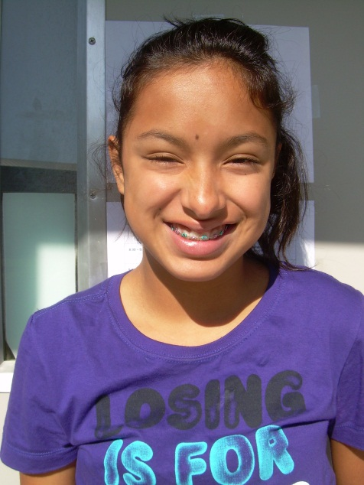

Summer Vacation
By: Abril G.

For my summer vacation I like going to the beach in Santa Cruz or sometimes even going to the lake in Modesto with my mom, dad, and cousins.

Going to the Santa Cruz beach is so fun because you can ride so many rides, like when I rode the captain ship and when I rode that chairs. I was so scared but it was also fun. I love it when I go with my family because my cousins and I get to build sand castles and we get all sandy. It’s weird but fun.

When we go to the lake, my uncle takes his boat and we ride with him. It is so fun because he goes superfast and you can feel the nice water splashing on you. I love doing fun things with them. When we go, we often have BBQ to eat. I think that is really good.
I like summer because I love hanging out with my family and making good memories.

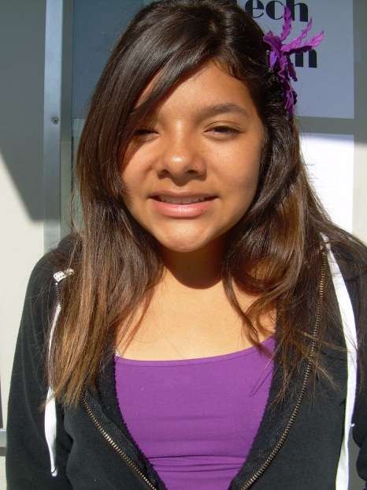
When My Baby Brother Was Born
By: Alondra P.

On August 9, 2012, my baby brother was born. It was midnight when I woke up from a noise. I went to my mom and dad’s room and I saw my mom packing. She told me she was going to the hospital because the baby was coming. My mouth dropped to the ground. The doorbell rang and I opened it. It was my grandma. She told me she was going to stay with my brother and me. When my dad helped my mom to the car, I told her bye mom and love you. I saw the car drive away, when a tear of mine fell to the ground. I was happy that my brother was coming soon.

It was 8:30am when we left to school. It was a normal day of school like always. When the bell rang to leave, I checked my phone and I had a lot of messages. They were all pictures of my new baby brother! I was so happy that I started crying. I wanted to see my baby brother so badly, but I had to wait for the longest time because there was a problem with my brother. He had to stay there for a while. I was only able to see him in pictures that my dad would send me. When I came back from school, the car was in the drive way and I knew they were home. I ran in the house and there he was sleeping! I asked if I could hold him and they said yes. When I was holding him, he opened his eyes and they were red. I asked my mom why and she told me the story.

When my mom was giving birth she stopped pushing, which made the baby get stuck! The baby stopped breathing, which made his eyes red! When he was finally out, he wasn’t crying, and my mom didn’t get to see him until later that day. They had to take him to the back because he drank all that liquid that made him stop breathing. When they were done they gave him to be with my mom. He was all better, he just had red eyes. When my mom was done telling me the story I asked her if the red in his eyes would go away and she said yes it would!

Now he is 9 months and getting bigger. He’s almost going to be 1 years old. The red in his eyes is gone now!

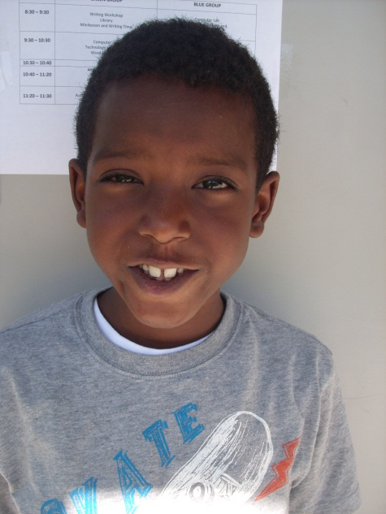

Football
By: Amare S.

My favorite team is the Raiders. I like them because of their trophies. They beat the Ravens in the Super Bowl. One of my favorite jerseys is the silver and black jersey. One thing I like is that they have good catchers. My favorite position is offense. I like offense because they score touchdowns. I went to my first Raiders game when I was seven. They played the Cowboys and they won. I really like football.

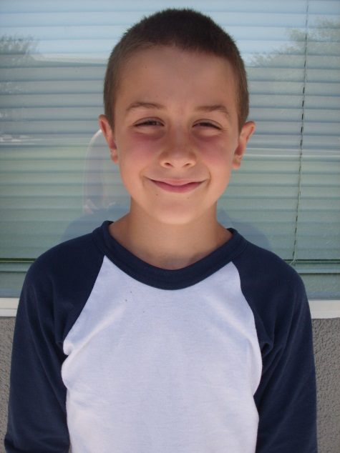

The Robbery 1973
By: Andrew Ma.

“Oh man I’ve been robbed!” “Mom we got robbed!” “How do you know?”, “Dad’s 10,000,000,000 dollars is gone!” “Uhhhhh, you’re right!” “I need to solve this mystery today but who could have done this?” “Someone must be acting suspicious.” “I’m going to go all the way around the world!” “Ok have fun.” Eleven months later…“Honey you’re back so early!” “There’s a lot of stuff you don’t know about me.” “Wait a minute there is only one person who could have done this, JUSTIN BEBER!”

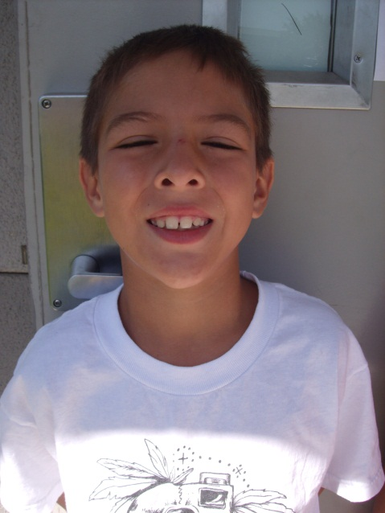

My Wallet
By: Andrew Mu.

Oh no! I have been robbed and they took my favorite wallet. This wallet was my first wallet. My wallet had Lightning McQueen on it and it was pretty cool. He was my favorite when I was younger.

I left my wallet outside overnight. The next morning when I woke up it was gone. I was scared. There was $5 in my wallet. I was mad that my money was gone because I was going to use it at Disneyland. I did not tell anybody that my wallet was gone. I looked everywhere for two days. I stopped looking for it when I ran out of places to look. I didn’t even tell my family because I wanted to find it on my own. I never saw my wallet or my $5 again!

Now I am older and I don’t really miss the wallet because I have three wallets now. My new favorite wallet is the one that has a skull on it. My second favorite is the blue and white checkered wallet. And my last one is the all purple wallet. I don’t need my $5 that I lost anymore because I have more than that in my piggy bank. So I guess it is okay to lose things because you can always replace it!

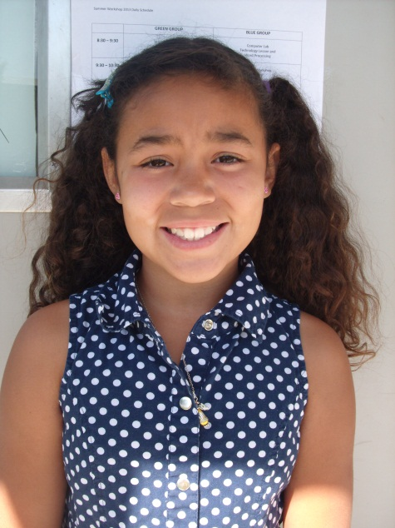
My Car Accident
By: Arielle C.

One sunny day, we were driving to a business meeting. Another person was asleep at the wheel and he hit us. The person that hit us drove into the grass and hit the wall. I didn’t know what was going on because we just started spinning around. I was scared, but my dad saved us by stepping on the brakes before we went out onto the grass. My brother hit his head on the window and he got a red bump on his head. The police came and checked on my brother. My mom went to check on him and she said his eyes popped like in a movie. The police also checked on the person that hit us to make sure that he was okay. After that, we moved on and we drove to the business and we made it there without another crash.

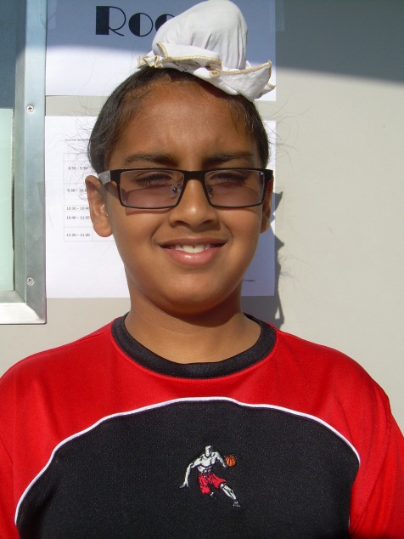

Meeting the Best Basketball Player
By: Armanpreet S.

When I met my favorite NBA superstar, Kobe Bryant, I met him when he was practicing for the 2010 finals. He asked me to be the Lakers coach since I knew every single play that they ran and they won the final game 136-123. The Lakers won the series 6-4 against the Boston Celtics. Kobe was the Finals MVP and the NBA MVP. Kobe scored 64 points, 10 assists, 4 rebounds, and he made 16 3-pointers. Kobe gave me one of his jerseys, a shooting sleeve, a pair of knee bands, and 10 pairs of his shoes (I picked them). He also gave me his phone number, so I could practice with them. The Lakers were very nice to me. They let me practice with them for free too! I still get to practice with them.
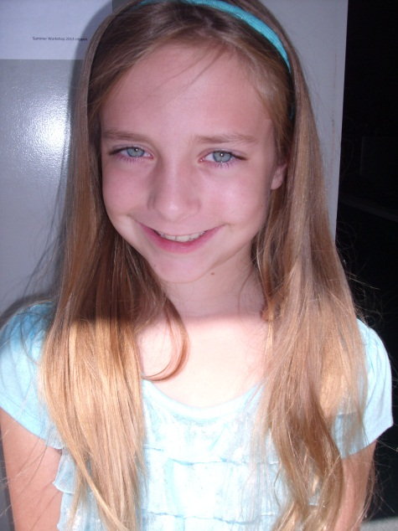

My Family
By: Ava D.

My family has four people: my dad, mom, Alec, and myself. They are friendly and entertaining because we like getting ice-cream together. We especially love camping in Big Basin. I like to play with my dad’s sling shot while I hope to hit a raccoon to put it in a coma with Mo and my Bro.

We have a ton of fun at our friend’s house while Mom and Dad are with their friends at the gym. I am a girl scout and both my mom and Mrs. Bridget are leaders. We went to a horse riding lesson and one of our girls, named Madiy, couldn’t come so one of my friends, named Emily, came instead. We had tons of fun when we gave our horses names. My horse’s name was Montana. I wanted this horse named Diamond but Emily got her. Montana, well let’s just say he was a great horse.

Soon I will be going on a trip all by myself where no parents are allowed except if they are part of your troop. This place is really high in the mountains and it has cabins and tents. I’ll be sleeping in a cabin. Do you want to know a secret? It is like a boot camp where the Daisies and little tiny Brownies room cabins looks like they have puke smudges all over the mattresses and the Juniors thank God I am a Daisy because the Juniors have way more cleaner beds. They ring big bells to let you know that a project is happening to wake you up and to tell you “lights out.” We will have building, swimming, archery, canoeing, arts and crafts, and horse riding lessons with Montana. I will stay there for five days.

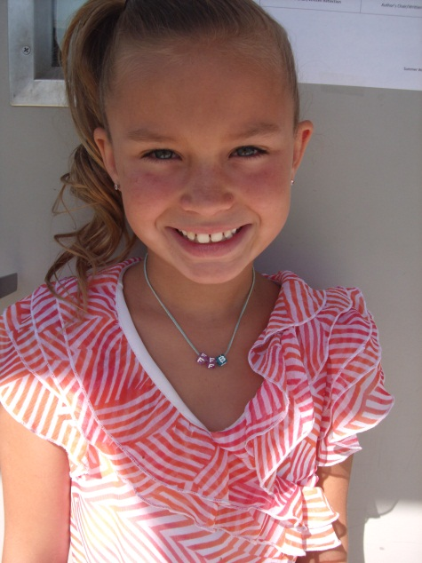

Meow
By: Briley H.

“Meow what happened?” Someone stole my tail. I have to find it. I went over to Mrs. Crippen’s house and I saw that she had a yellow and black tail on her desk. It looked just like my fur because my fur is yellow and black. I asked my owner to talk to Mrs. Crippen and she said, “It’s just a plastic tail.” We went out to look at it and it was a plastic tail because we didn’t know if she was telling the truth or not. We went over to Mrs. Spears’ house and we didn’t see a tail that was close to mine. We went upstairs and I didn’t see it anywhere. I looked everywhere and I never found it. I looked in three rooms and looked under the bed but it was still not found. I went over to Mrs. Dooley’s house and I asked her if she had a yellow and black tail and if she saw it. I went and then she said no. I looked on the street and I saw a dog with a yellow and black tail in its mouth. I asked my owner to grab it out of his mouth but it was a real tail and my owner put it back on me but it doesn’t fit me. My owner said, “You might not have a tail, but maybe you lost your tail and the police might have it.” So I went to the police’s house to see if they could find it for me. Then they saw something under the couch, it was there the entire time! I didn’t know it was there but I finally found my tail and I didn’t have anything to worry about.

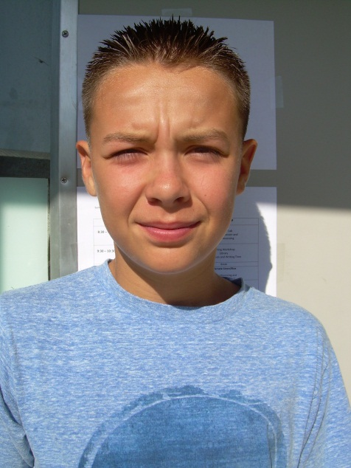

The Beach
By: Cameron C.

What I like to do in the summer is go to the beach. The beach that I like to go to is Santa Cruz because it is close to my house. If we could not go to Santa Cruz then we would go to pebble beach. The time of the year that I go is in June. When I go, I take a friend so I am not bored. I took Jason and Dylan last year to the beach with me. Sometimes we turn on music. We like any music. When we go to there we go on rides and to the boardwalk. We like to ride some rides at night. We go into the stores that are next to the rides. The ride that I like is bumper cars. We like to look at clothes and we look at the sunglasses. The things I see at the beach are people in the water. A lot of people like to find sea shells. Sometimes people bring things to dig with. What I smell at the beach is the salty ocean water. My friend and I like to go eat on the boardwalk.

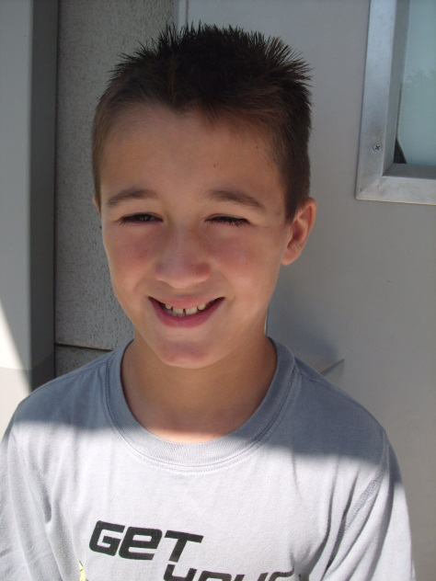

My Watermark
By: Carson S.

I dug my first hole when I was five, in my backyard. My dad let me dig a hole in the backyard because I wanted to. I knew it would be fun.

While I was digging I saw a dead gopher just lying there. I saw a worm, a map, and then a book. Then I got mud all over me. I took them to my room and put them away. I was done digging for the day.

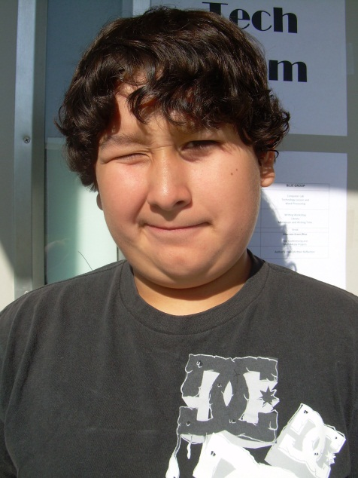

The Time I Went to Disneyland
By: Cesar M.

Last year I went to Disneyland. It was so fun because I was able to ride on all the rides. My favorite ride is Space Mountain because it goes really fast even though there is always a long line. I guess it’s because everybody loves that ride. I was anxious and excited at first when we were driving up to Disneyland. When we arrived, I was so happy that l almost died because I was really looking forward to go to Disneyland. However, it took forever to get into the park. When I got in the park, I was rushing to every ride but my mom said slow down because I was pulling her to get on the rides. My sister, my dad, my mom, and I rode on the Abominable Snowman and it was so fun. Then we went on my most favorite ride in the world, Space Mountain. They took pictures when we were still riding the ride and I was laughing when they took the picture. At the end of the ride they said, “Do you want to purchase pictures?” Mom then bought the pictures and my face looked funny. Then we went on another ride called the Matter Horn. It was okay but it wasn’t as fun as Space Mountain because Space Mountain can go 0 miles to 90 in one second. The Matter Horn starts off slow but then it goes fast. For Space Mountain, however, it starts off fast. I love roller coaster that start off fast and I first rode on a fast roller coaster when I was seven. After we were all done riding Space Mountain I told my mom that we are not leaving the park until we ride all the rides in the park. My mom said it was fine and so we were able to ride all the rides. Afterwards, we left the park and we were all tired so we went back to the hotel and we went to sleep. I had so much fun at Disneyland and I will always remember it.

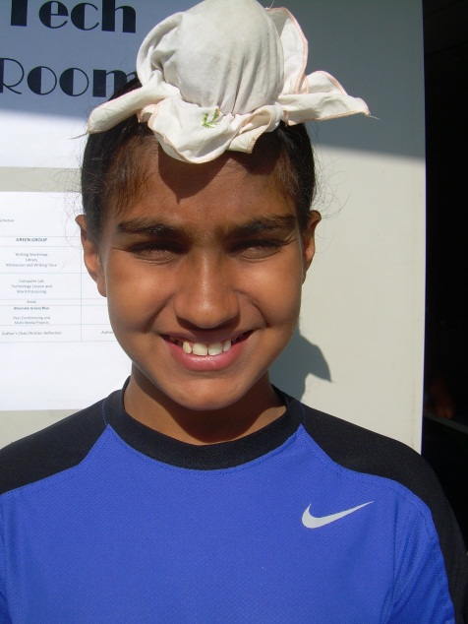

My Dog Bit Me
By: Chanpreet S.

My dog’s name is Daisy. She is a German Shepherd puppy. She has black fur, a brown face, and blond legs. A month ago, I went in the backyard to get food for Daisy. She is often hyper in the morning. I went to pet her and she started to bite my hand. I yelled because it really hurt. I felt very scared and I started to shake. She didn’t let go until I said “Stop!” My hand was bleeding and I was crying alone. I felt worried she would still bite me. I ran to the garage to get away from her. The next day she started to chase me and but she didn’t bite. I think she felt bad that she bit me. I had a scar on my hand. She doesn’t bite anymore because she knows I will yell stop.

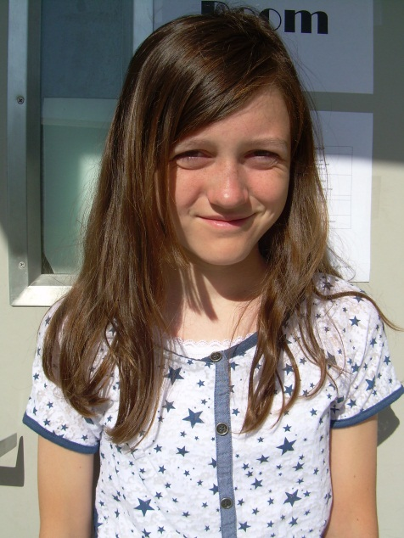

Hume Lake
By: Claire C.

The summer of July 2011, my family and I went to Hume Lake. My brother’s birthday was going to be on July 15th. We were going to go camping in Sequoia National Park and visit my brother, Cameron, who lives there. The ride there was long… almost four hours. I got a really good nap out of all that. I listened to music too. I watched all the stuff go by out the window. There were a lot of orchards, bushes, trees, houses, dirt, and mountains. That’s about the time I got bored and fell asleep.

When we finally got there, my brother was waiting patiently for us at our campsite. He helped us set up. He visited every day until we had to go home. We saw the lake and rode our bikes around it. My brother drove us around on the small twisting roads, showing us his current house, Joshua Lodge, and some of his friends. My favorite place was the general shop. It had this SUPER delicious ice cream, pink lemonade ice cream. When you walked out of the general shop, you could see the Lake. It was glistening in the sun.

After all that we went back to our campsite. We had brought some chips with us. When we opened the lid, the seal looked like a balloon about to pop. We were higher up in elevation where there is less air so they can fill up with more air. We set up a hammock between two tall pine trees. It was very relaxing to lie there and look up at the prickly pine trees and the clear sky. At night, we would sit out and look at the stars. Since we were higher up, we were closer to the sky and the stars were really bright and shiny. We looked for satellites. Satellites move as fast as an airplane, but they look like stars. We also were roasting marshmallows. I didn’t like roasting them because they were so gooey and sticky. So I just raided the bag. At night, we went to sleep in our pop-up camper. My family has had it for years. I can’t really describe the smell, but it didn’t smell bad. There was a faint smell that smelled like my grandma’s house.

I woke up to the best smell in the world; BACON. I got dressed and ran outside the camper to where my dad was cooking breakfast on the compact stove. I wanted to eat it all, but I had to save some for the rest of my family. After that, we rode our bikes around Hume Lake. If you looked closely, you could see some cottages through the trees. I didn’t really see any animals besides the ducks on the lake and birds. It was neat sitting by the lake. You could see a dam on the other end.

Finally came the day when we had to go home. I was sad. This place was almost like Disneyland! Except without the rides… and castles, and princesses; although, I can do just fine without the princesses. Hume Lake was so beautiful. I also didn’t want to leave my brother. The drive back was just as boring as the ride up, except the ride up was totally worth it. The ride back was also very depressing. Every mile I knew I was going further and further away from my brother. You would watch the mountains go back behind smaller mountains, and then hills. Hume Lake was one of the best experiences in my life and nothing has topped it, yet.

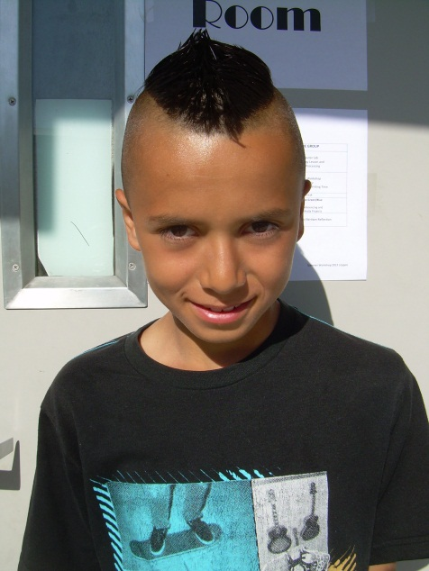

I Got Bit in My Eye
By: Cristian P.

On June 21 2007 I was at my house playing with my big dog named Oreo. Oreo and I went outside at 3:00pm to play catch with a tennis ball. Oreo found candy and ate it. Oreo threw up because he ate the candy. I began to panic. I grabbed him and started running. When I was running he bit me under my eye then I fell and scrapped my whole stomach. I was bleeding a lot. I went inside my house and I was crying. My mom was really scared so she took me to the hospital. I had to stay at the hospital for two days because my skin got an infection. Oreo jumped out of my hands and scrapped his stomach. When he scrapped his stomach, he got a cut on his stomach too. Oreo had to go to the hospital to get stitches. I was CRYING A LOT because he had to get stitches. Three days later Oreo was well enough to come home. The next day, my dog was much better so we went outside to the backyard to play. First, I made sure that there was no candy on the ground. Then Oreo and I started playing catch. Oreo and I, we’re all better!!!

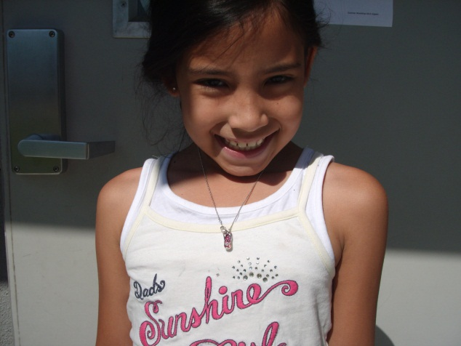

My Water Mark
By: Diana D.

When I had an accident my mom, dad, and sister had to take me to the hospital; it was super scary. I had to stay at the hospital for two whole days and people brought me toys. On the next day when I opened my eyes, my mother was happy that I was alive. The doctor said I can go home, but I wouldn’t remember anything till June 1st. Then it was June 1st and I remember everything and me and my family were very happy. Then my sister had an accident like one year later. It was panic attack but it was not that bad of an attack, just a little less than okay. Let’s just get back to the story; her attack was taken place in downtown San Francisco.
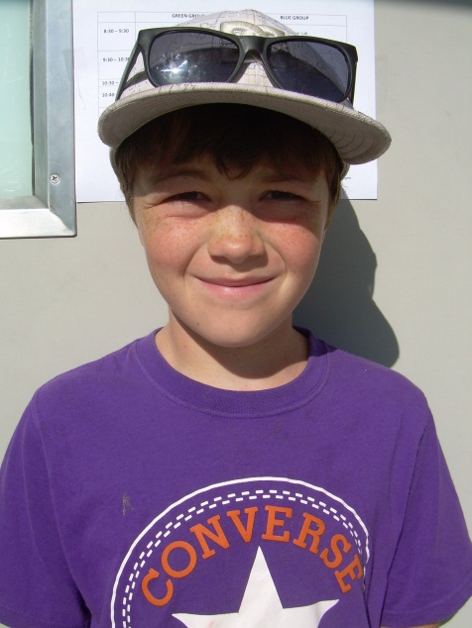

My Watermark
By: Dillon B.

My dirt bike is my life. I love it so much!!! I love it because I won 10 races in one year and it was awesome. I like riding my dirt bike because I get to meet up with friends and win races. I found my dirt bike at a dump. It started out as a hood and a gas tank but over the years I have fixed it up a lot. I spent over 200 dollars fixing it up. I have learned that racing a dirt bike is about having fun and to not win every time.

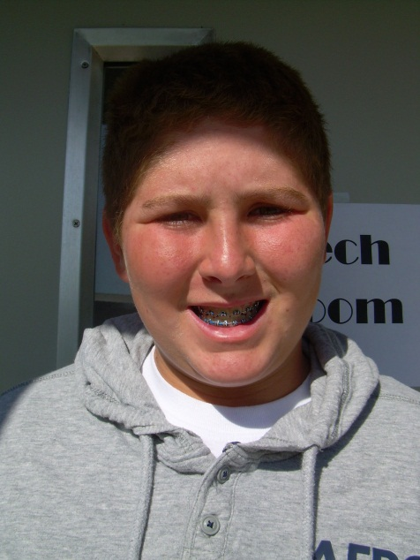

Summer Vacation
By: Dylan G.

If you don’t know what I like to do on summer vacation, then keep reading. I love to hang out with my friends especially Cameron, Ryan, Zach, and Jacob. I’ve known Cameron and Ryan since I was born while I’ve known Zach and Jacob for about 6 years now. I met them from baseball and basketball. Sometimes we spend the night at each other’s houses.

I love to watch movies all the time. It’s one of my favorite things in the whole world. I like movies about baseball, superheroes, or any other action movie. Usually after the movie we go eat dinner. My three favorite movies are Iron Man 3, 42, and Fast and the Furious 6.
Sometimes during the summer, I sleep until 11:00 a.m. or I wake up at 7:00 a.m. just to play video games.

I love to go swimming no matter how warm or cold my pool is during the summer. My pool is around 80 degrees. But my friends’ pools are like 85 degrees.

During summer vacation I always like to go to waterparks. This year we are going to the Roseville Waterslides. I have been there before with my friends. On our way back we go to Round Table that is right down the street from the waterslides.

After that, we head on home to play Xbox after we drop my friends off. We play online and we talk about how much fun we had.

It always sucks when summer is over. Then when you are in school you just want to get gobbled up by sharks all day, but when you go back on summer vacation you feel like nothing can stop you until the feeling of getting gobbled by sharks again.

This is what it’s like if you were me on my summer vacation.

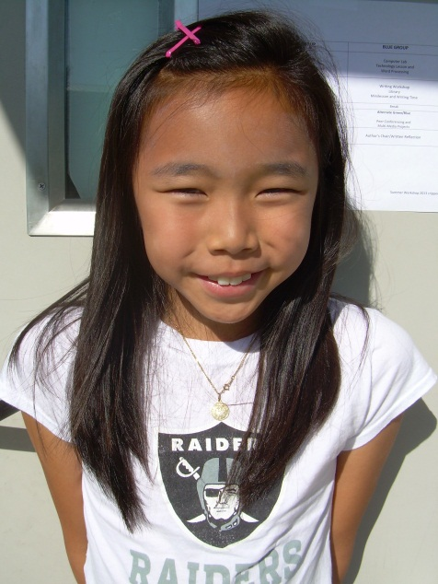
My Watermark
By: Ellie K.

When I was in third grade, my best friend, Sofia Maxey, was very angry at me, and on the last day of school too. So I was in school thinking what a wonderful day and summer I would have then suddenly first recess started and I went over to the big blue playground. There was the coolest thing that had just happened; everybody was doing the conga! But I did not want to do it, even if my best friend gave me V.I.P cards for us to go into the front.

So when I was playing freeze tag with my friends Chris Galcia, Connor McClure, and some others, it was time to go inside the classroom for some activity fun. That was when something happened; we got more recess time. “NOOOOOOO,’’ I screamed. It was the first time I had ever been sad about recess because I didn’t have many people to play with since almost everyone was doing the conga. All of a sudden, Sofia went on to join the conga line when she saw me doing something else. She started yelling at me and then suddenly the recess bell rang. She called me lazy, slowpoke, and she even called me a coward and unfit. But the worst thing she called me, actually two things…was a dork and a nerd. I was a crybaby by that time and that really hurt. When my friends heard me wailing away, they called a yard supervisor and I had very red eyes. When my teacher saw me she asked the people who saw what happened to me and my friends explained everything.

Then last recess started, and that was when tragedy struck. Sofia and I went to the playground and then she started chasing me. She said I was going to pay for making her not going to the conga. This made me very surprised! I was the one who did not let her go! What?! I said she could go to without me. I must have made my mistake. She started punching me and I kept shouting, “Are you my best friend?!’’ Best Friends would never have done this. That was when I went down, PAUSE! Okay, now we are back to where the horror struck. So once when I got to the ground, she ALMOST kicked my face. But I quickly dodged and I ran for my life to Mrs. Penny, a supervisor, and told her everything before *pant* Sofia came over. She was about to punch me when she saw that an adult was silently watching. Then she tried to look innocent because she knew that every time she did that everyone fell for it, except me. But this adult grabbed both me and Sofia and we rushed over to our teachers. She apologized and when the adult was not looking and she whispered something, “I will get revenge someday, crybaby!” Suddenly the adult heard all of it and almost made her come home early but instead, they called our moms and told them all about it.
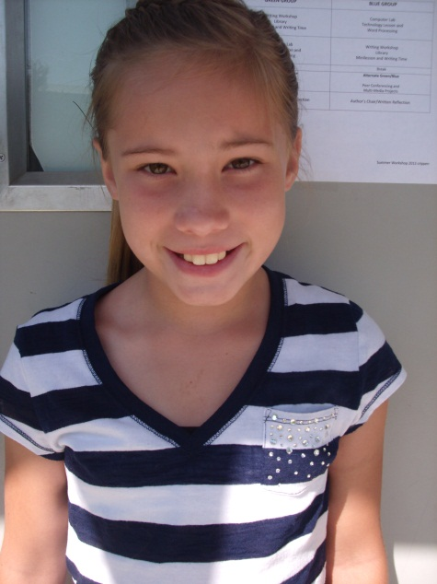
Mystery of the Lunch Box
By: Emma M.

It was a normal day in Manteca and one of my friends Maiya was with me at school. It was time for lunch. We had brought lunches but Maiya couldn’t find hers. It was purple with green polka dots. We looked everywhere but no sign of it!

I decided to call it Mystery of the Lunch Box. She actually liked the idea, ALOT. She called the S.W.A.T. Team and she even called the Air Force!! I was shocked but it was her lunch box.

The S.W.A.T. Team looked everywhere! Even 30 feet underground all around the city!!!

The Air Force looked everywhere too! Then Maiya thought of one place that she hadn’t looked at yet. POP! She had it! Her backpack was the only place she hadn’t looked yet. She unzipped her backpack took a peek and out came her lunch box. She started laughing her face-off!! So did I!! We rolled all over the floor and when we were done we called everyone and told them how and where we found it. They were laughing a little too! But now we can’t find her wallet…

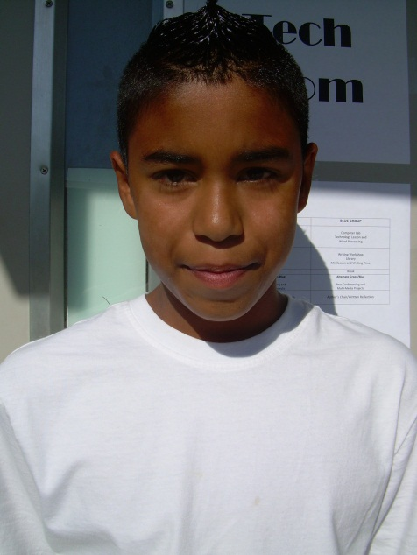
My First iPad
By: Giovanni P.

I got my first iPad was when I went to my grandpa and grandma’s house. When my parents went to go to a store, my grandparents and I went to Walmart to get my iPad. I was excited because this was going to be my first iPad. Right when I entered the store I felt like I was getting little bumps on my body. When I saw the iPads, I wanted to hold the box because I already knew the iPad was already in there. When my grandparents were paying for it, I asked if I could get a case. They said, “Yes but hurry up because we’re going to pay already.’’ So I looked at the cases quickly and I found the perfect one. It was my favorite color green. When we went to the house, my mom was surprised that I had an iPad and a case with me. I kept saying thank you to my grandpa and grandma and they said, ‘‘You’re welcome.’’ My mom still couldn’t believe that I got an iPad because the iPad cost a lot of money.

When we left, my grandma and grandpa’s house I couldn’t wait until we got to our house because I couldn’t connect it to the internet. I had to wait until we got to our house. When we got to the house, I ran out of the car, into the house, and next to the computer. I told my mom to hurry up, but she told me that I have to have patience. While it was loading, my dad told me to clean up my room. So I did it fast so I could go use my iPad. Once I was finished, my mom was done with my iPad too!!! So I got my iPad and started to get apps, but I had to go to sleep early because the next day we had school.

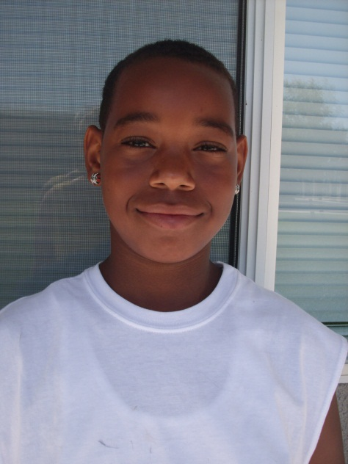
The Stolen DS
By: Harold G.

“Oh no my sister has been robbed!’’ I look under the bed and it was not there. I looked under the coach, in the bathroom, and in my mom and dad’s room but it was nowhere to be found. I looked in her room but it was not there. After I checked all the rest of my house, I went to my room knowing that she did not know where it was. I pulled open my drawer and there it was lying in my underwear.

She was sleeping and I took it from her Justin Bieber bag and I put it in my Angry Birds bag. We left the next morning.

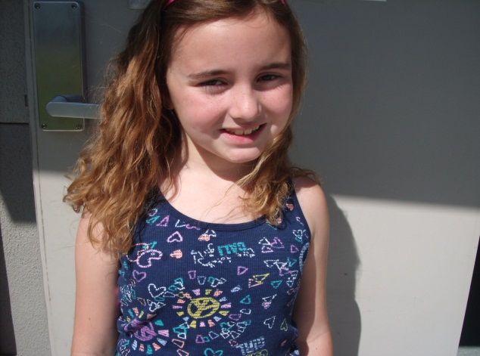

Cats
By: Isabella I.

Hi I’m Isabella, and I have an obsession. I have a love for cats. Cats have been in my life for as long as I remember. I got my first cat when I was in Preschool; my mom gave it to me. Now I have a total of four cats and I’m so happy they’re in my life.

My first cat was Ozzy. He has big green eyes and a big belly. Ozzy is my biggest cat. His fur is a beautiful coat of black and white: it reminds me of an Oreo. Ozzy is my favorite cat, I have had him the longest. Our love is strong even though we are far apart; Ozzy lives in Alabama.

Champagne is my second oldest cat; she is also the only female. She is very sassy, and can sometimes be mean. She walks around like she owns the place, with her big fluffy tail. She acts like she’s the queen of the house, but my mom is. Talk about a cat fight! Champagne and Alvin bite each other in the morning, and sometimes bleed. It’s okay though, it’s just play fighting.

You’re probably wondering who Alvin is; Alvin is my third oldest cat. I named him Alvin after the chipmunks because he is wild and has chubby cheeks. Alvin has gray fur and green eyes just a little darker than Leroy’s. Alvin’s eyes are best compared to leaves. He is my cat and sleeps in my room. I enjoy his company. I love Alvin and I feel a special bond because he is my cat.

Lastly, the smallest of the liter: Leroy. Leroy is the newest member of my cat family. We just got him last Wednesday. He has big jungle green eyes and he is black and white like Ozzy. Leroy is 8 weeks—he is a baby. He is sometimes a troublemaker, and can be mean at times, but for the most part is very nice!

I love cats; they make great friends, and family members. I love all my cats equally; they’re all so special to me. My name is Isabella, and I have an obsession.

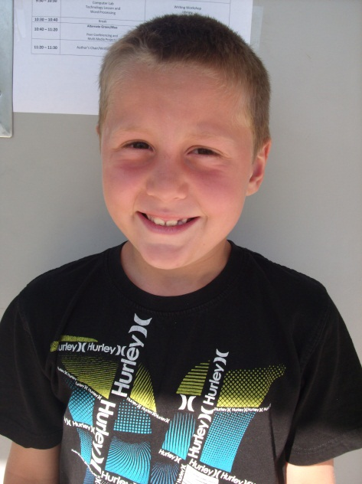
Birthday Head Bump
By: Jacob C.

It was the morning of my birthday party and I had just turned seven. I was so excited for my party that I started diving into the pool early morning. Then I decided to try and do front and back flips into the pool. It was my first time that I had tried doing that. The first few flips, I was doing just fine, but when I tried one of my back flips my head hit the side of the pool. I hit the cement! Fortunately, I didn’t crack my head open, but I did hit my head hard enough to get a bump right on the top of my head. I swam to the pool steps, and I went inside the house to tell my mom that I hit my head on the side of the pool. She immediately put ice on my bump to make me feel better. I had to keep the ice pack on my head for about an hour. By the time my friends arrived, I was doing just fine. Even after my little accident, I continued to do flips on the pool with my friends. We had lots of fun in the pool, we played games, and we ate cake. Then I got to open all of the wonderful presents my friends and my parents gave me.

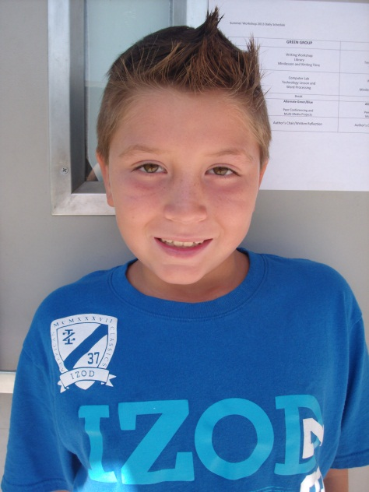

Maui
By: Jarrett E.

First we took a drive to the Oakland airport. Then we got on a jet that took five hours to take us to Hawaii. That was fun because we got to watch a movie. We landed in Maui airport and it was around 12 noon. We got our suitcases, rented a rental car, and we drove to the hotel.

First thing we did was to look around and then go swimming at the hotel pool. The next day we went to the beach and had fun snorkeling. We went out on a boat to Malakini to continue snorkeling. We got to snorkel by a coral reef. We saw an eel while snorkeling. While on the boat, we saw a lot of whales which were pretty big!

We went back to the hotel and had lunch. We went to an old place called Lenhina and got shaved ice. I even got a keychain that said my name in Hawaiian, which is Kei. That’s pretty cool.

The fourth day we went to the beach and met some new friends. My dad and I got surf boards and caught some waves. While we were surfing, my mom was getting that Hawaiian tan.

The next day my grandpa, my family, and I went to McDonalds and drove the whole Hawaiian road of Hana. While on the road we saw Oprah Winfrey’s house.

The sixth day we went into the forest and saw some amazing things. We came back and went to Black Sand Beach and went surfing again, but this time my mom went with us and she fell which was funny!

On the last day we went to visit the pool and beach one last time and visited an aquarium. We saw a shark try to catch a whale but the whale put up a good fight from our hotel porch. Then we bought a pineapple and went on a cruise ship.
We took a long plane trip home and my friends were happy to see me. I thought the vacation was really nice; it was the first time I had ever been to Hawaii. I’d like to go again!

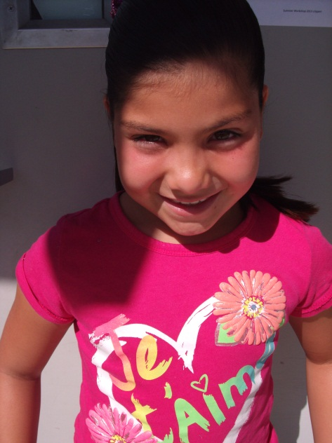
Rule the World
By: Jessica A.

If I were in charge of the world I’d cancel kissing, bad words,
Scary stories, and strawberries

If I were in charge of the world there would be 200 books you have to read in one day
Birds would not have sharp beaks and sharks would have no teeth.

If I were in charge of the world, a person who…
Bites their fingers nails,
Eats food off the floor,
Doesn’t brush their hair,
Would still be allowed to be in charge of the world.
Because I’m in charge of the world, and I make the rules.

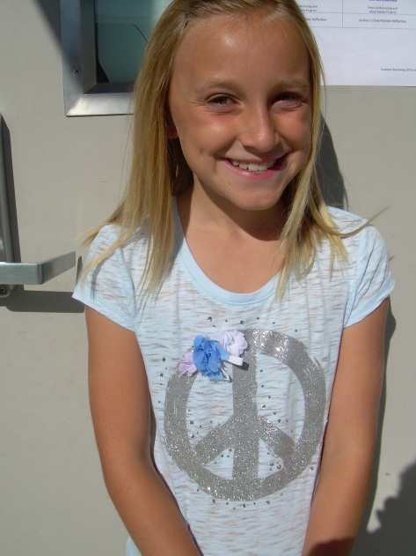
Ericia
By: Jewleah B.

Ericia was the best coach ever! She would push us until we got it just right and would reward us by not giving us so much conditioning. Sometimes I thought I couldn’t do that much conditioning. But she would tell me that I could and guess what? I did it! However, she wasn’t just an awesome coach, she was a great cheerleader. When she was at Power, she cheered on level 5! Sadly she moved cheer gyms. She broke my heart because she was my coach for 4 years! Now she cheers for the C.A Bullets and coaches tumbling classes at Famous. She said she loves her team so I’m happy for her, but still it breaks my heart. I think about her at every practice. She was a great coach.

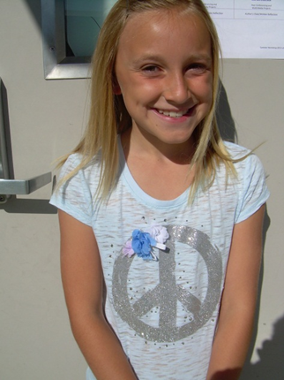

Who Stole the Cheese?
By: Jewleah B.

“Hurry!” yelled Mrs. James. “What happened?” Mr. James asked. “Someone stole my cheese that was on top of the dresser!” Mrs. James called the police. The police rushed into the car, started the engine, and pushed the pedal all the way down. The car was speeding down Main Street to get to the house. As soon as Mrs. James heard the siren she rushed to the door and flung it open. She could barely talk because she was so frightened and worried.

Mrs. James told every mouse in the city. All the mice were just as frightened as Mrs. James. The police asked over and over again “Are you sure you looked everywhere?” Time after time Mrs. James would say “Yes, I’m sure.” The police also asked if anyone looked suspicious. Mrs. James said, “Well the giant, as other mice say, is the owner of the bug house.” “Well” said the police, “How has he been suspicious?” “He has been walking by our hole a lot!” “Ok I’m going to stand by the opening of the hole and watch him.”

After a few minutes the police stopped watching. He said that the giant hadn’t walked by once. He also said that she should look around the house again. So she looked around and didn’t find it. Finally, she remembered that she left it on the counter. They all laughed and laughed.

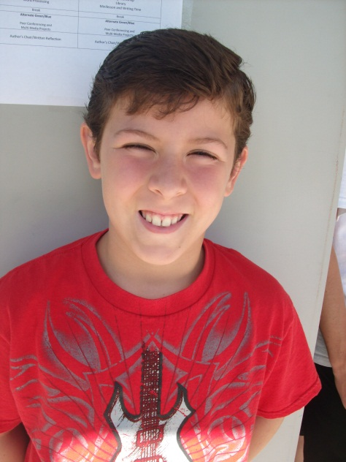

Scars
By: Johnpaul C.

One of my most memorable scars is on my right knee. I was seven years old and I tripped off the steps at the park because I was rushing up towards the slide. I was just on the second step when I fell and hit my knee very hard. My knee was bleeding a lot! I was in a lot of pain and I was crying my heart out as I tried to make my way towards my dad. He was sitting on a bench talking to someone and didn’t even notice I got hurt. When he saw me he was surprised and wondered how I got hurt. He rushed to help me. He quickly cleaned me up with his sweater and had me sit with him on the bench for a while. Then we went home and my mom looked at my knee and put a bandage on it. She hugged me and said that it was going to be okay. I ended up with a small scar on my right knee and like my mom said, everything was just okay!

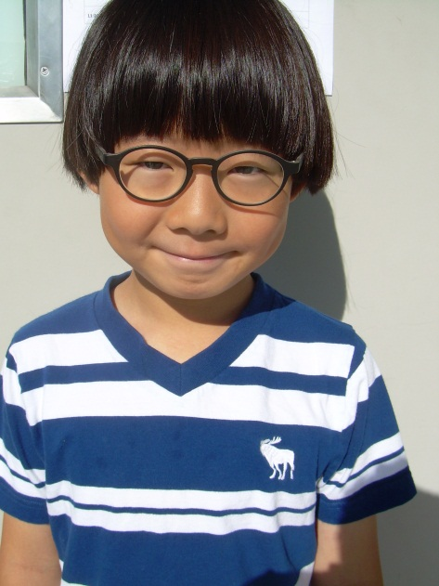
Bicycle Watermark
By: Joon P.

When I was 8 years old, I rode my bicycle so fast that I fell and slid on the ground. I couldn’t go anywhere for a whole 4 to 5 weeks. My leg was hurt. My friend was helping me to get home after I fell off my bike. He was my best friend in Korea. He was very helpful when I got hurt. My friend carried my bicycle. I couldn`t walk very well after I fell off my bike. My mom was very surprised that I fell off my bike. Thank God that I didn`t have to go to the hospital. My mom put one big bandage on my leg. I still remember that watermark in my life, but I want to forget about this watermark.

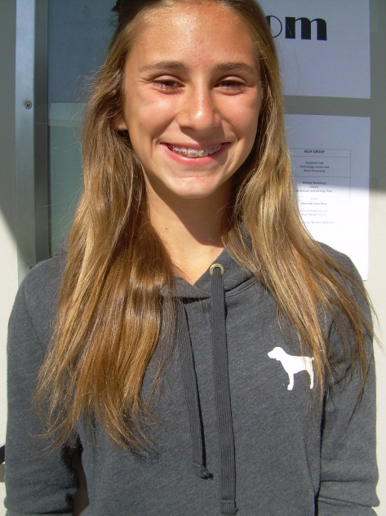

Who Stole My Bone?
By: Josslyn B.

I am NOT a morning dog! I keep my bones everywhere. I even keep some right under my bed so as soon as I wake up in the morning I can chew on a bone or two. But this morning has already gotten off to a bad start. “My bones are missing!” Right when I noticed, I went down a couple of doors over to the Garcia’s. The older man in that house was a police officer. He had his own police dog too, her name is Fluffy. I told Fluffy about the robbery. He came back to the house with me and investigated the area. There was no broken glass or any footprints. There was no evidence for Fluffy to work with. He told me there wasn’t anything to work with and that he needed to head back inside.

I told Fluffy the next day that I had suspected Shaggy. Shaggy is the Johnsons’ dog. He is always in everybody’s business and that lately he hasn’t been talking to me. He normally will have barking wars with me through the fence. He will shout my name hollering “SPOT!” That night I just lay in my dog house thinking of where else I would have put the rest of my bones. “THAT’S IT!” I blurted out so loud that I think the neighbors could have heard me. I had buried some under my house and hid some under Marcy’s bed right next to her old box of toys and clothes she stuffed under there when she “cleaned her room”. Marcy’s my owner. I go inside every once in a while and get petted by Marcy. She will take me in her room and lay with me on her bed and sometimes when her best friend, Jack, comes over, they will both play with me. When she was downstairs I snuck some bones under her bed so I could eat and get petted. I hid the ones under my house because I needed to lay off some of the bones, but I can’t live without three bones a day. One in the morning right when I wake up, sometimes two, one after my lunch, and my last one at night before bed.

I crawled out of my house and used all my might to push it over some, but I only got it half way to where I needed it to be so I could get my bones. I hoped that Fluffy was awake still, but I went next door to get her for some help. I told her how I thought and thought and finally remembered where I placed my bones. He easily shoved the house over and helped me dig up the rest of my bones. We found my bones and I thanked Fluffy for all her help. I told her to remind me about the ones in Marcy’s room too. After Fluffy went back home, I went inside my house and had a bone and ever since I lost my bones, I have dug a hole in my house. The hole in my house is bowl shaped, so now I always put my bones in there.
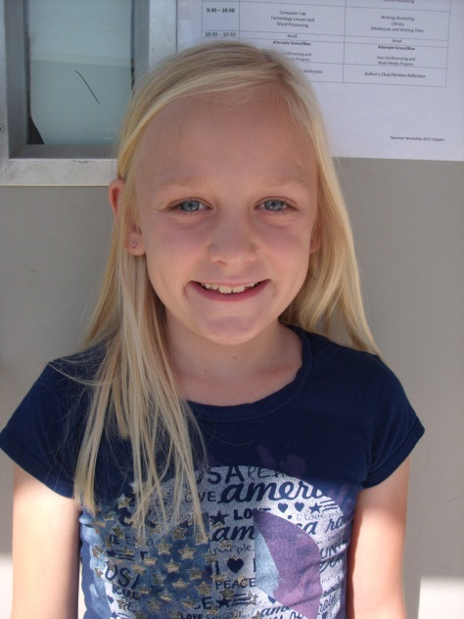

The Crime
By: Kailey B.

One day my mom stared at her left hand and had seen that her diamond wedding ring was gone! My mom was very scared, worried, shocked, and panicked. She looked everywhere. She tore the couch up, the car, and then the whole house. She looked in her purse and at work. Then she asked the family. We all said we never saw it. Then my mom walked by Suka’s cage and saw something shiny. She took the shiny thing out of Suka’s dog cage and found her wedding ring. She was so relieved that she found her wedding ring.

My Watermark
By: Kailey B.

I got my broken finger when I was at gym. We were playing tag. I was going down the slide and the kid moved so I jammed my finger into a metal wall. My finger was so red and purple. My finger hurt so badly. I still played tag because I did not it was broken. After gym was over I went home. When I was home my mom got me some ice so we can ice my finger. The ice made it feel a little better. The next day we went to the doctor at 2:00 P.M. the doctor put it into a splint. They said it was just fine now. The next they said it was broken. That’s how I got my broken finger.

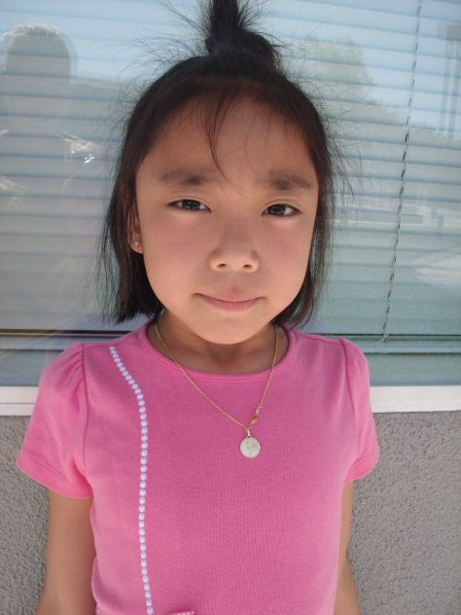

The Carmel Mission
By: Katie K.

Let me tell you about the Carmel Mission. It was made in 1772. It was burned two times. It was rebuilt in 1778. We got to see a living room, bedroom, and a library. When we went to the garden, we took a lot of pictures and I do not like taking pictures. We went to a gift shop and looked around. I like The Carmel Mission!

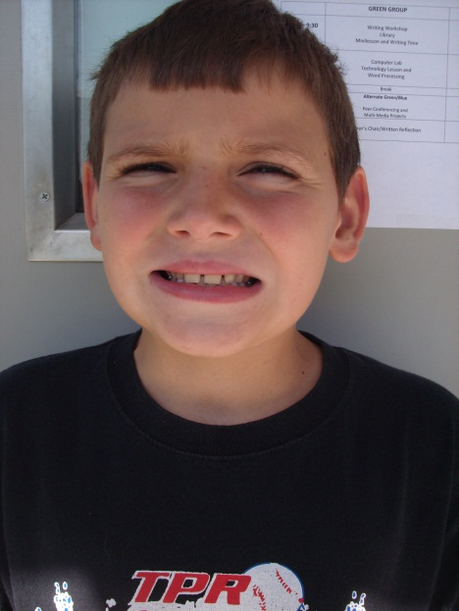

My Skateboard
By: Konnor S.

When I got my first skateboard for my birthday, I was excited! I road it in the house and then I went outside. It was fun, so much fun! It had skulls all over the bottom. On the top, it was black. The outline was brownish- orange. The wheels were black and they spin fast. Whenever I went outside, I would skate on it and then jump off onto the grass. It was a lot of fun. My wells were green with black skulls. My first skateboard trick was flipping it. It was so cool I did it again. I asked my mom if I can go to the skate park. I had fun at the skate park. I stayed at the skate park for a long time. There are nails on the top of it. I did a 360 degree spin in the air. I fell off it so hard I broke my helmet. I rode it at the park.
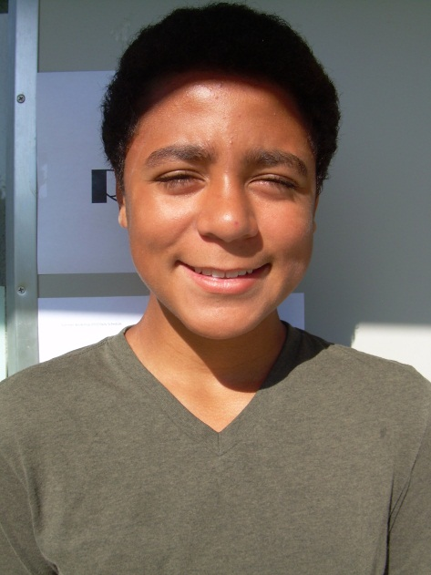

My Watermark
By: Kylan C.

One night when I was 8, I was lying in my bed playing with a rock. I tossed it back and forth above my head carelessly. Then I dropped it, it fell into my mouth, and slipped right down my throat. I swallowed a rock! The next morning I told my mom all about the rock and what happened. She called the school and then we went to Doctor’s Hospital to get x-rays. After the x-rays they told us that we had to go all the way to Oakland Children’s Hospital and that I couldn’t eat at all that day. That was the worst. I couldn’t eat anything from 6 am to 7 pm. Thirteen straight hours of absolutely NO FOOD, it sucked! The next morning I woke up early, before 6, so that I could eat a lot of food. I practically inhaled a bowl of cereal. Most of the ride to Oakland was me endlessly pleading my mom to get me some food, but she said no consistently. I was already hungry when I got into the car, so you can only imagine how hungry I was when I got to the hospital. When we got to the hospital I was starving, and seeing people walk around with food trays made it even worse.

Then we finally started the procedure. The nurses gave me laughing gas and that other stuff that puts people to sleep. All I remember after that was “This stuff isn’t working, Ha ha ha…” and then I fell asleep. That stuff actually does work pretty well. I was asleep the entire time, all I can remember is this crazy dream about flying monkeys and giant rocks, it was pretty weird, they just kept laughing at me. Then I remember waking up with a terrible sore throat and a bag of pork rinds. Even though I had a sore throat I ripped through that bag of pork rinds and the Olive Garden takeout that came after. But it was all over and I could finally go back to school. Even though it felt like I swallowed a rock.

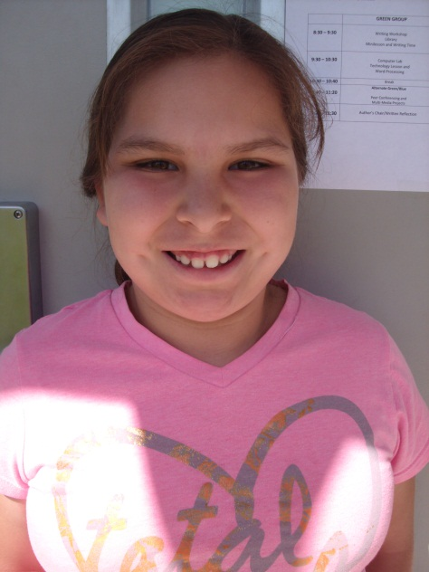
If I Were in Charge of the World
By: Liliana N.

If I were in charge of the world
I would change war into baseball
I would have money and medicine trees

If were in charge of the world there would be no making fun of people, no fighting and there will be pet shows

If I was in charge of the world a person who
Draws,
Plays baseball,
Reading,
Would still be allowed to be in charge of the world.

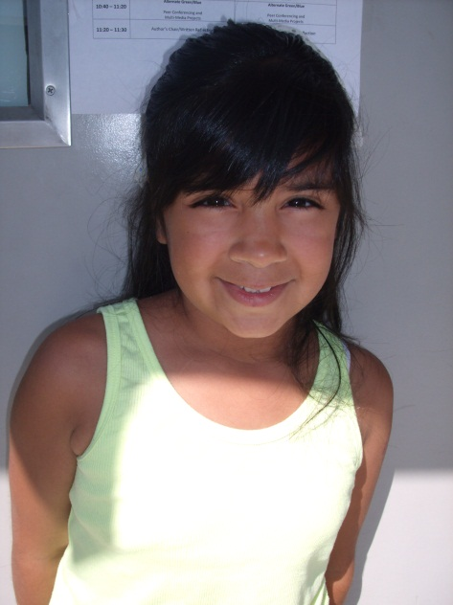
The Mystery of the Food
By: Madison M.

AHHH! Help I have NO food! Screamed Tux! It was a dreary rainy in Manteca when Tux realized all his food was gone. “I wonder who stole it”, said Tux. “Yay I wonder who “, said Panther. Panther is day a girl she could get mean and selfish sometimes. “Maybe you can check with my kittens” said Panther. “Ok Tux. Ok,” he replied. “Hello?” “Hi!” “Who said that?” “ME!” “Oh ok. I’m Kittysoftpaws.” “Oh cool I’m Tux! Can I talk to you Kittypaws?” “It’s Kittysoftpaws! OK?!” “Ok so where were you at 9:00 sharp! Well everyone was in the empty alley, when this knows where I was, all happened!”

AHHH! “I feel horrible”, said Tux! Who did steal my food? How will I talk to the dog in the next house he will eat me! I have to go now I wish myself good luck talking dog I hope he won’t bite my head off. Hello are you hearing I will come back later then. “Wooof! Woof! Wooof! AHHHHH! Help! Help!” screamed Tux. “Do you want,” said Sam. Um I want to ask you something but before I start can I have dog food I am extremely hungry! Sure why not! But are you sure? “Yes,” said Tux.

“Did you ever still food,” said Tux? Actually I haven’t! Sorry I have to go my owner is home! Bye! Bye tux! Thank you for food Amy! But there is only a little! “I know it’s a little Tux but I have to go to soccer practice”, said Amy. Bye Tux! Meow! Tux replied. Mittens! Mittens! “Where are you”, said Tux. Meow! Mittens! “You stole my food”, said Tux! “But why did you stole my food”, said Tux. “I don’t know I was to Tux I was to hungry to think about it,” said Mittens. You could of just told me if you were hungry so just don’t steal peoples stuff anymore okay Mittens! Okay next time I will tell you Tux! Thank you Mittens.

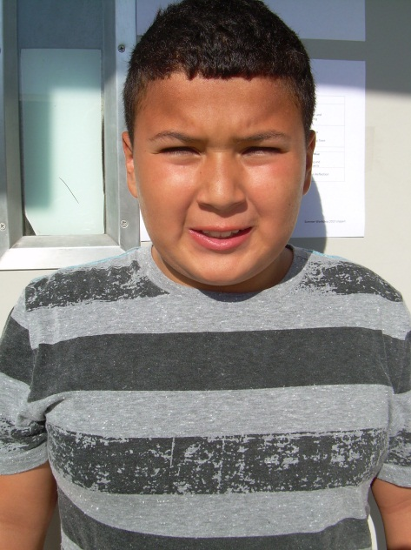

My Watermark
By: Mariano C.

I have a scar on my left leg. I got it when I was in track. I went to long jump when they said “Go!” I ran, I timed my jump wrong, and I did a flip and hit the ground with my left foot and it started to bleed real badly. My friend Ezra helped me and my mom got me a paper towel. A track staff brought a Band-Aid. I was in a lot of pain. It got infected but I did not go to the doctor. My dad put peroxide on it but I kept picking my scab. After a few months it became a scar on my left leg. This is how I got my scar on my left leg and it was big.

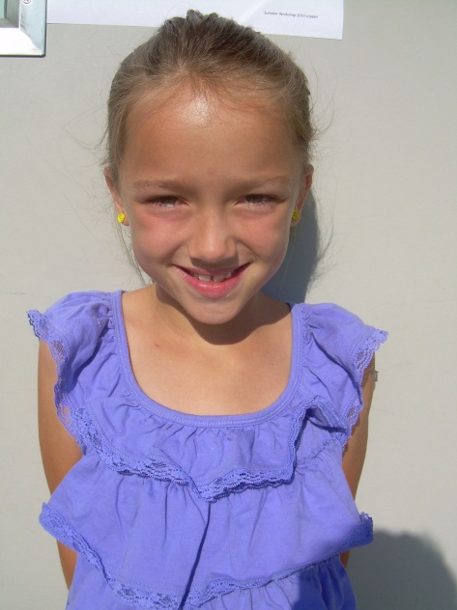

Best Trip Ever!
By: Marly G.

My family and I woke up at four o’clock in the morning and we zoomed to the airport. Then we waited a very long time in the airport for our flight. We boarded the plane and took our seats; finally it was take-off.

We were on our way to Florida; we were going to Potter World! Then we entered our hotel, it was so big! We used that day to rest and the next day we went to Potter World. First we went to the castle and went on an awesome ride. My favorite day is when I went on the Flight of the Hippogriff. I went on it twice; one time with my parents and one with my brother. Then I watched a band play and they were pretty good. After that I went swimming; the pool was very warm and super crowded. Then we went out to lunch with my mom’s friend Donna. I had a super yummy burger and I won two items from the machine; a teddy bear and a football player.

After four awesome days I flew home. I didn’t want to go home, but we had to. The plane ride was five hours long, which felt like forever. Finally we were home, and we got home at midnight. I was super tired, but it was worth it. I had so much fun; it was the best trip ever!
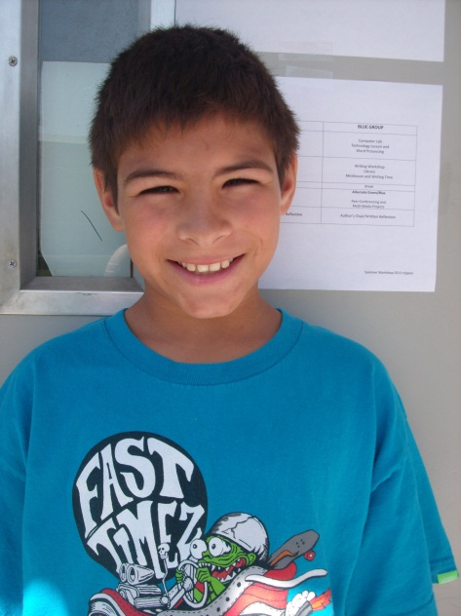

The Wallet Crime
By: Matthew M.

My favorite wallet that had skulls on fire was stolen from me! My wallet was under my softest pillow on my bed. It could have been my cousin, Von, who had stolen my wallet. He steals my stuff sometimes. I kept my wallet under my pillow so that way my brother doesn’t steal my wallet. I have found my wallet! Von stole it from under my pillow. He threw it on the grass when he was going to Canada. My five dollars was still in my wallet when I got it back. I caught the thief!

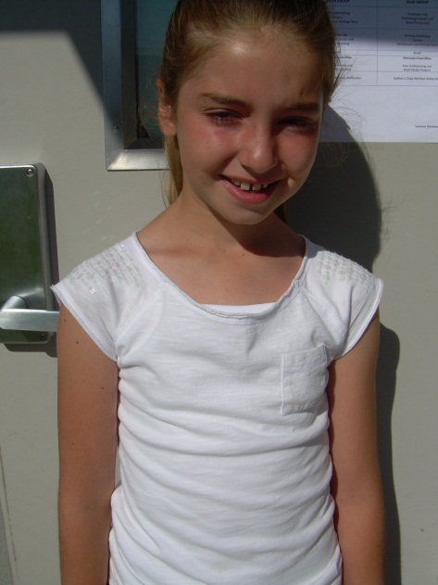
Our Family Trip to Hawaii!
By: Mia W.

A little while ago I went to Maui. It was really exciting! I got up at 7:00 in the morning. Then we drove to the airport. It took us about an hour to get there. When we reached the airport a nice man helped us with our bags. Then we had to put our big bags on a scale to make sure that they were light enough to go on the huge plane. Then we waited for my beautiful cousin to get to the airport while we were waiting we got something to eat. Then finally my aunt and my cousin arrived at the airport. To get to the security we had to go on a little train. When we arrived at the security we had to take off our smelly shoes and walk through an automatic censer. After that we stopped at a marvelous shop so we could get some yummy snacks for the plane. We got all kinds of snacks. Then we went and sat in the comfortable chairs and waited until we were ready to load all of the kind people on the huge plane. When they were ready to load us we got in the long line. When we got up to the helpful counter a lady, she checked our tickets. Then she let us through. We had to walk through a long hall way to get to the plane. Then we got to the door of the plane. We steeped in and we found our blue sets. Then we put our entire luggage in the shelves on top of us. When we were just about to take off the pilot realized that we didn’t have enough gas. It took us about 20 minutes to get gas and fill the gas tank. When you are taking off the plane has to roll on its little wheels before it takes off. We were not allowed to turn on electronics until we were at a certain height. When we were on the plane a lady came around and gave us delicious peanuts. After you get the peanuts they give you a minus. All of the stuff on the minus was really good. When you are high up in the air everything looks like Legos. When you get high enough to turn on the electronics they let you rent DVD players. My cousin and I got really bored after a while so we started playing games and board games. We also ate candy. Inside the plane the restrooms are really small. When I was walking to the restroom there was lot of turbulence so they made me go back to my seat. When you start going down to land it really makes your ears plug. Except if you were me because for some weird reason my ears never plug. When you are about to land the plane puts out its wheels. When you land it kind of shakes you a little bit. But when you land and you look out your window it is beautiful. When you are getting off the plane you have to get your carry-on luggage out from on top of you. Then you have to wait before you can get out. When you are getting out of the plane the pilot says I hope you enjoyed your flight and you say thank you for flying us today. When you are in the airport you have to go to a spinning thing that gives you your luggage. After you get your luggage you go and rent a car. My grandparent, my brother, my mom, and my cousin went to get the car. My aunt and I stayed with the luggage. I was happy I stayed because my aunt and I got Starbucks. My aunt and I both got smoothies and we also got a piece of cinnamon bread.

My family arrived with two cars. We were really hungry so on our way to our hotel we stopped at McDonalds and got lunch. It tasted really good. Then when we were driving to our hotel we saw whales in the distance. Then we got to our hotel it was really nice. Right after we got to the hotel we went swimming. There was a slide but it was already closed. So we just swam. Then it started to rain. The rain was warm. Then after a little while we had to go back up to our hotel. The next morning we were really excited to get down to the beach. When we went down we went in the pole first. The slide was open so we went down the slide for a little while. Then we went down to the beach. The first day my cousin got really sun burnt. It was really fun throughout all of the eight days. We had my brother’s birthday there. For my brother’s birthday we went and did the fish pipe. The fish pipe is a giant blown up ball that that you go inside and you run around in it. There were only a few in the world. I also caught a gecko. But I let it go. When we were snorkeling we saw a big sea turtle lying on the ocean floor. It was really exciting to see it. I have never seen a sea turtle in real life before so I was really excited. We also made puka shell necklaces. They were really cool. I still have mine. It took us a really long time to make them. It took us about an hour. We wore our puka shells for the rest of the day. One time my cousin and I left our shoes by the pool and then we found them the next morning. After a couple days we had to move to a different hotel. That hotel was nice to but I liked the first hotel better. It wasn’t our favorite beach either. There were huge waves and a lot of people got hurt. I was swimming in the water and then all of a sudden a big swell came in and I was stuck out there. My dad came in and got me. My aunt tried to come get me but she wasn’t big enough. So she lost her sun glasses. After a couple days it was time to go home. When we got to the airport nobody wanted to go home. When we got on the plane everybody was sad. The plane ride was really fun though. We got to rent the movie player again. It only took us four and a half hours to get home. That is really short. We had a great time. We were all sad to leave but we needed to get home. Besides we wanted to see our animals. I had a really great time I would definitely go back again.

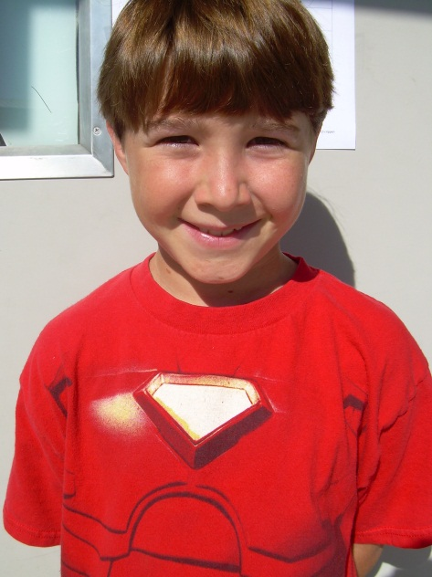
Minecraft
By: Mike R.

Minecraft is an amazing world on the Xbox, PC, and phone. You get to do whatever you want. Minecraft is a block game and a block game is a game made of squares. There are three types of worlds: the first one is Creative, the second one is Survival, and the last one is HARDCORE!!! In the Creative world you cannot die, so in the Creative world you get to build whatever you want to. You can build castles, houses, jails, and a lot more stuff.
The next one is Survival world. In Survival world you have lives and you have to find your own resources to survive. You need to build everything out of your own materials. In Survival you have to explore carefully so you don’t die. You can build a giant house or a tiny house. You can explore caves and ravines. In those cave or ravines you can find abandon mineshafts or a rare strong hold. Mineshafts are abandon mines. You can find lots of budder (a.k.a gold). You can also find Redstone, Diamonds, Lapis Lazuli, and Iron. In strong holds you can find the End portal which I will talk about later. When you are on land you could find villages. In the villages you will find villagers, whom you can trade, items for stuff.

There are different biomes. The biomes are snow, swamp, extreme hills, flat, forest, water and jungle which is my favorite biome!!!!!!!!!! These biomes are located in all the worlds.

The next thing I will tell you about is the two portals. The first one is the Nether. In the Nether there are ghasts and zombie pig men. There is fire and lava everywhere. The ghast is a big square ghost that shoots fire balls out of its mouth. When the fire ball hits something there is a huge explosion and the impact shoots your guy back a little bit.

The last portal is the End portal. In the End Realm you will find Endermen and ENDER DRAGON!!!!!!!!!!!!!!!!!! The Endermen are harmless until you look in its eyes or attack it. When you make it mad by one or both of those ways, it will try to kill you. They will teleport to you and away from you to try to get you. The last part of this portal is about the ENDER DRAGON. The Ender Dragon is the final boss. It is super strong. The first thing is the towers in the end, and they will heal the dragon. That is what you have to do to kill the Ender Dragon, and you have beaten the game.

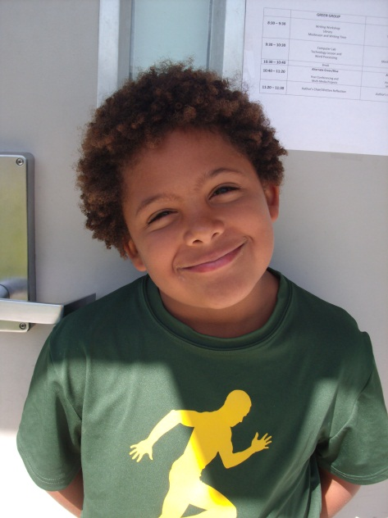
Summer Time
By: Noah L.

There are tons of things to during summer. Some of my favorite things are surfing, swimming, camping, having Nerf wars, and just relaxing. During the summer, I’m a lazy bum! Last summer my family went camping with the Burtons and the Crippens. My favorite trip was with the Crippens at Sea Cliff. It was tons of fun! We played whiffle ball, used the metal detector, went swimming, and found sand crabs. The sand crabs were really creepy! I love camping during the summer! It’s my favorite time of the year! People should always go camping in the summer because it’s a fun way to bond with your family!

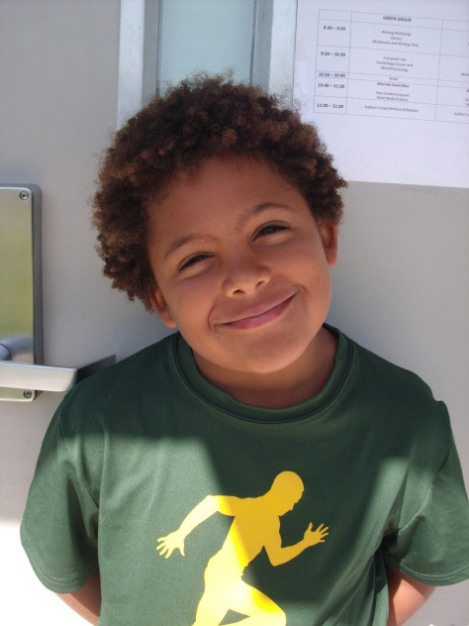

My Favorite Place
By: Noah L.

Fishing, surfing, swimming, baseball, video games, school, and trampolines. Although I like all these things, I like Disneyland the most. Disneyland is the happiest place on earth! It is filled with Disney joy, laughter, and excitement. My favorite rides are Pirates of the Caribbean, Buzz Light-Year, and Toy Story Mania. When my family went I was only six so I didn’t get to ride any rollercoasters. However, I did get to ride a dragon kiddie roller coaster. I don’t remember everything but I do remember going on the Mickey Mouse Ferris wheel. The view was amazing from up there! Disneyland is the greatest amusement park I’ve ever been to! Disneyland is the greatest land in the world!

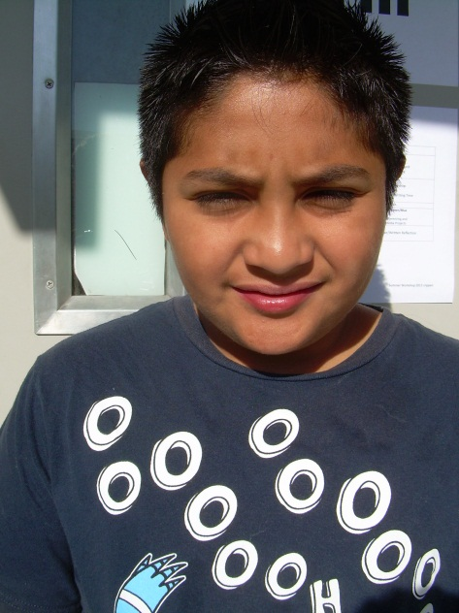
My Water mark
By: Nolen G.

It was my 11th birthday I invited my friends. When they all got there we went bowling there was a deformed light blue bowling ball it looked like an egg and we called it Arlena. We called it my sister name. When we got home we watched scare face and we called it Arlena. Then we watched Wassobe Production there was a girl called Rolona and we called it Arlena. When they left my sister was hitting me until I got a bruise.

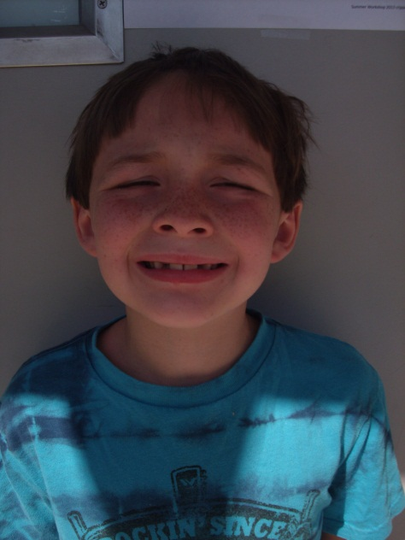

Motocross
By: Patrick B.

Motocross is awesome! I love riding a 50cc. Dirt bike. A 50cc is the size of the bike and engine. My dirt bike is red, that’s my favorite color. Motocross can be very dangerous because you can go very fast and you can get hurt. Also the course you ride on can be tough. My brother and I both ride dirt bikes. I would like to go pro on day. I want to be as good as Travis Pastrana, the best dirt biker. You have to wear certain clothes while riding: a helmet, pants, and a long sleeve shirt. I hope to only get better and hopefully teach my own kids one day.

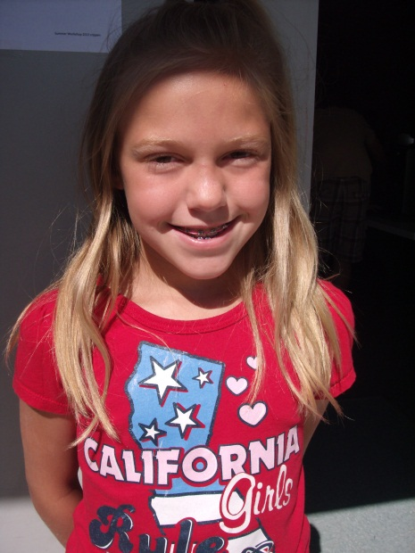
Preston Gets Robbed
By: Rebecca T.

“Come on Carson we need to- ahhhhh, where did the car go?!” Preston asked. Carson and Julie came running from their room. Preston looked around and screamed, “Guys, the car’s gone!!!” As they covered their ears from the screech in Preston’s voice, they retorted simultaneously, “Calm down!” Preston was shocked, that they weren’t as surprised as he was, where was the car? Why were they so calm? Why weren’t they freaking out? What the heck is going on here? “Is there something I should know about guys?” said Preston. “Yeah,” Julie chuckled, “We moved the car down the street.” Carson pointed north, and Preston turned his head in the direction of Carson’s finger. He was astonished that he didn’t see that. Julie couldn’t stop laughing, she thought it was just so funny, but really it was just some kind of sick joke.

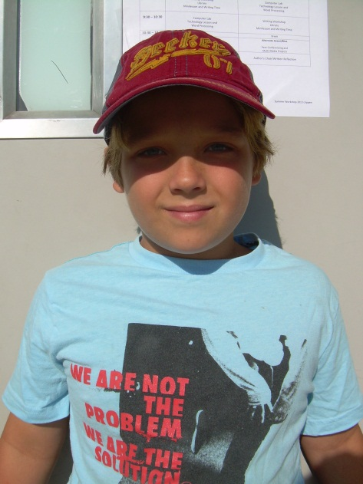

The Worst Water Mark
By: Reed G.

My water mark was when my grandpa died I was really sad. We don’t know how he died, but we know he had a heart attack. I don’t think he deserved it. He was a good coach, he helped me play baseball, and he would play catch with me when I came over to his house. I wrote about this because I usually would not write about this because it is sad but he was such a nice grandpa, coach, and friend. I loved him with all my heart. It left a big hole in my heart. He went were nothing bad ever happens, and that is what makes me feel okay. He was fun to be with. This event was really sad.
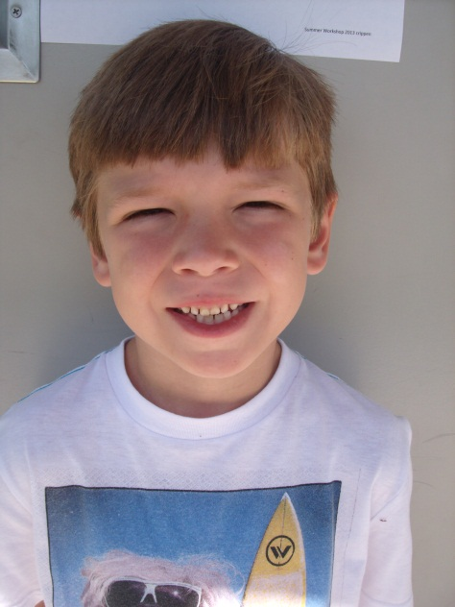
The World Series
By: Rex W.

Baseball is my absolute favorite sport of all time. I love baseball. My favorite team is the Giants and my favorite player is Buster Posey. He plays catcher. The Giants made it to the World Series last year and they won it all. In the World Series they went into extra innings and the Panda, also known as Pablo Sandoval, hit a home run to win the game! I was super excited! I was so excited I slapped my sister in the face! I didn’t even get in trouble! I hope they win the World Series again. Although I like the Giants, I also like the Athletic A’s. My dad is also an A’s fan. My favorite player on the A’s is CoCo Crisp. I hope the A’s have a good year as well. You should play baseball because it’s lots of fun.

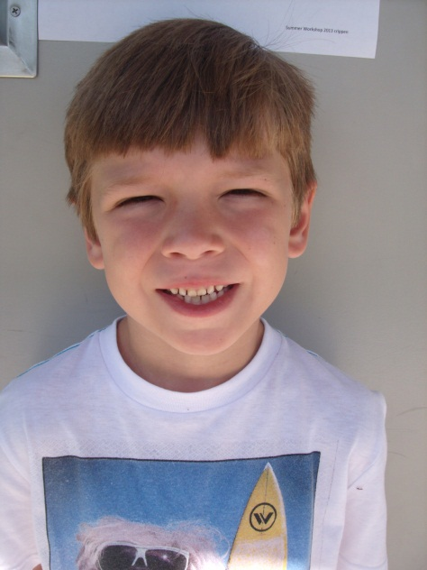

The Robbery
By: Rex W.

“Chcue!” They were asleep when they heard the glass break. They woke up, rushed down the stairs, and noticed they’ve been robbed! When they looked by the T.V. they were confused. The Wii was gone! They called 911 and the police came over quickly. They whined and cried like a little wittle baby without his baba! “My Wii, my precious Wii! They took it!” They could have taken pictures or dishes, anything but this! But nothing could help them. The Wii was gone forever! It wasn’t until two years later when they finally bought a new black Wii.

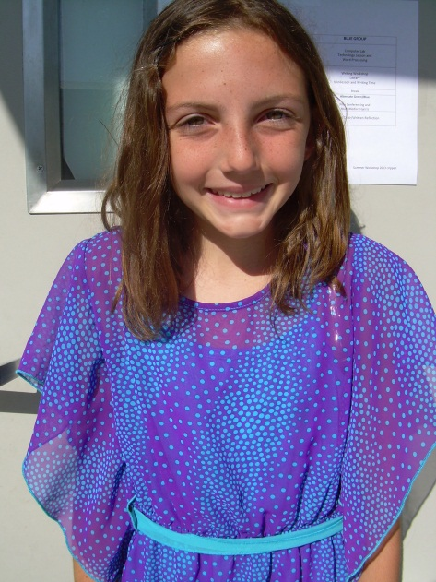
Who Stole the Mouse?
By: Riley P.

“Fat Cat! He’s been to my house! He went through my cat door!” “AHH! Whoa, whoa, whoa calm down Squeaky,” said Fido the dog. “What happened?” “Fat Cat took my toy mouse! Fat Cat was at our house ‘lockdown!’ He pretended like he was talking into a loudspeaker and said “this is not a drill; I repeat this is not a drill!” Don’t be ridiculous Fido, he was already here there is nothing we can do about it, said Squeaky. Sure there is and with that he jumped into the air and yelled, Super Fido to the rescue! Now you are being even more ridiculous. Now let’s just go down to the canine police dog, Spot, so he can help us with the investigation. So the two siblings went to the police dog, Spot and told him the story about the robbery. The police dog followed them back to the house and started his investigation. He dusted for paw prints with his duster, and then he looked in the dog house and the kitchen. There is still no sign of the toy mouse. After that moment, Spot started to give up, but Squeaky stopped him and said “No, no, no you’re not giving up now!” You’re finding my toy mouse whether you like it or not. Ok, said Spot and he went to the store and bought Squeaky a new toy mouse, but she knew that the mouse was not her toy mouse. She said, nope don’t try to fool me, I know that toy is not my mouse. Have you seen a mouse that looks like a cow? So Spot began the investigation again, but still no sign of the toy mouse. Finally, Squeaky said, ok it’s been long enough, I want my mouse back and I want it now! So she ran out the door and headed straight for Fat Cat’s house. When she got there she busted through the door and screamed at the top of her kitty lungs and said “I want my toy mouse right now Fat Cat!” All of a sudden Fat Cat came out through a dark shadow and said in a low voice, “I don’t have your mouse Squeaky, you do.” Squeaky was confused, “what do you mean?” She said. You have it. It’s in Fido’s dog house it’s been there the whole time, said Fat Cat. Fido lied. He did know where my mouse was, he had it the whole time. Oh he’s in trouble now. So when Squeaky went home Fido was nowhere to be found so she went to his dog house, but the mouse wasn’t in there. She went to her bed and there was her toy mouse, lying right smack dab in the middle of her bed and she never lost her toy mouse again.

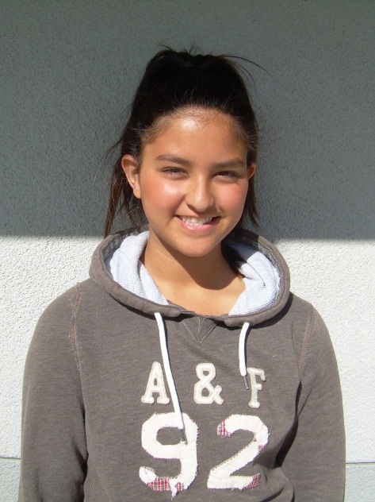
My Watermark
By: Rose A.

On my summer breaks I always go once a year to Atlanta, Georgia for a family visit. My dad’s side of the family lives there, and I usually go with my dad and older brother, but last year my brother was old enough to take me alone on a connecting flight there. Our first stop was at Houston, Texas and as soon as we said our good byes we got on the plane and there was a delay, so right when we got to Houston we only had twenty seconds to get on the Atlanta plane, but right when we got out of the plane we rushed and the plane had already left. We called our parents as soon as we found out the plane had already left. My mother and father were terrified and unhappy that they let us go alone. After they spoke to us we spoke to the front desk and they sadly said it was the last plane to anywhere. At this point my mom is saying they want us back in California. I was definitely home sick already. Since we were minors the lady working in the front desk told us to stay at a little hotel in the airport for minors because the next flight to Atlanta was at seven thirty in the morning, but it was closed.

My brother and I were tired of hearing bad news, so instead we called our dad and he booked the nearest hotel by the airport. After we went downstairs, got our luggage, and headed to a taxi. We finally got to the La Quinta Suite. When we entered the building the first thing the man asked working by the desk was “Where are your parents?” We told him that our father spoke to you did he not? The man said “Oh yes, yes he did but, he said you have an adult with you.” Well we told him, we don’t. And he said you have to be 18 years old in order to book a room, but thank goodness he told us he will let us in since we told him how our flight got canceled and all the bad news. While we went upstairs he was telling us there is free breakfast in the morning and there is dinner if you guys want. I never met anyone so kind and caring. The next day we woke up early, went downstairs, ate breakfast, and got in a shuttle to gratefully leave! When we finally got done with the security check and all the rough business, I lost my phone! I called, called, and called and went down to security but didn’t find it. Then my brother’s phone was ringing with my contact name on it. I answered and it was the man at the hotel, he said he will ship it to California. That was just awesome news for the first time! Soon we finally got on the plane and arrived gratefully in Atlanta, Georgia. We found out that everyone there thought we were dead or something. When my cousin arrived at the airport I didn’t want to say hi or I missed you I wanted to just cry, because I was home sick and paranoid.

When we finally arrived in Atlanta I honestly just wanted to sleep. It was tiring and I’m pretty sure sleeping would be a great idea because you don’t have to hear bad news every time. The lesson we learned was never to go on a connecting flight without an adult over the age of eighteen. We stayed in Atlanta for about 2 weeks at the most and I only had fun half of the time because I couldn’t stop thinking of everything that happened. Although I’m going to miss everyone, my dad called and he told us when our flight is and he told us the details, but we found out it was another connecting flight!! At Denver, Colorado right after the shooting, I just wanted to scream. When I got to the airport we had enough time to sit and relax for the Denver plane. We got on the plane and arrived in California, thank goodness. I got my phone, but I wasn’t worried much about it. I was worried most about having to ever go on a flight like that ever again.

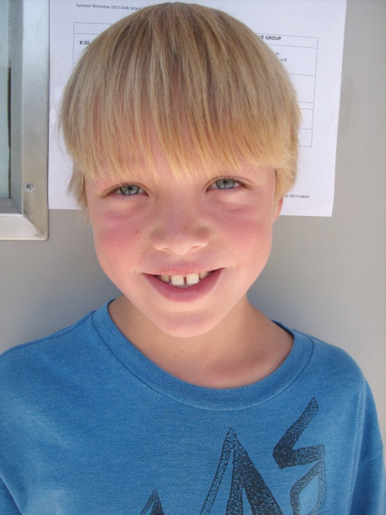

My iPod Gets Stolen
By: Ryan I.

One time when I was at Target, something unexpected happened. I was strolling in an aisle and I didn’t notice I dropped my iPod! Then, an hour later I left Target. I realized my iPod was gone! I turned around and retraced my steps. I looked everywhere! I even asked the workers if they found an iPod. They said that they hadn’t seen anything. When I got home I looked in the newspaper to see if they found an iPod. There was no luck. We looked around for about two years. Finally, I bought a new one. I still have that iPod that I bought. Now, I don’t take my iPod many places in fear that I might lose it.

I Broke My Collarbone!
By: Ryan I.

“Snap!” I broke my collarbone when I was three. I was reaching for an Ariel toy on the counter when I fell off and landed on my collarbone. It felt like a hammer shattered my collarbone! It was broke, and I had to go to the hospital. The doctors told me I had to wear a cast for a year. When I went to Disneyland I couldn’t ride any roller coasters. It was torture! My favorite thing I could do was take pictures with Mickey Mouse. I also watched my sisters have fun on the roller coasters and I wanted to do what they were doing but I couldn’t. At least I got to do the kiddie rides and I got a bunch of stuffed animals. At the end of the day, we drove home and I fell asleep on the way. When we got home I fell asleep in my room again. After a year we went to the hospital, they took my cast off, and my collarbone was all healed. I was super exited that I could finally do stuff!

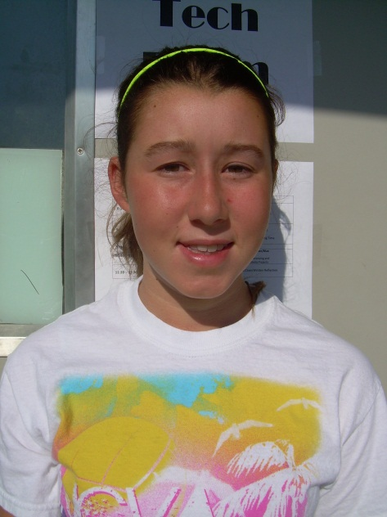

My First Club Volleyball Game
By: Taylor R.

The gym was getting intense and you could tell. Teams were piling into the 2-court gym. Our team watched as they came into the gym. The other teams all looked good and as they have played together as a team for years. We paraded into the gym looking as ready as ever. We were all there to play and win our games. It was the first tournament of the season.

My first Club Volleyball game was about to happen and I was a nervous wreck!! I had never played in a volleyball game before let alone a Club Volleyball game. I was also in the starting lineup playing middle back, right where every server serves the ball to!! I was shaking like crazy and I am not a relaxed person, so with all the pressure not to miss the ball was building up inside of me. Thoughts were also building up inside my head, “What if I missed the ball? Or what if I let my team down?” Finally it was the first serve of the match. Zoom! The ball was over the net and coming straight at me! I was praying that I would not mess up, but the point was over in a blink of an eye. In a few rotations I was subbed out and my coach told me to calm down and breath. We lost our first game of the season, but that was alright, we had fun playing the game.

We lost our second game that day too. Now it was time to play for elimination and if we lost we were done for the day. We played the next game and won! This meant we moved on to the next game and we won that game too!! Yay!! We were finally done for the day!! We got fifth place and that is awesome for us!! Most of my team, including me, were first year players or have never played before, so we rocked by placing for a first time!! At the end of the day we all wanted to go home and sleep! What a workout that day was! Go Club Manteca!!!

A Hawaiian Roller Coaster Ride
By: Taylor R.

The 5 cramped hours in the plane were long and boring. Finally we were outside Oahu’s airport and our legs were feeling normal again. We were bused over to budget, our rental car agency. My brother and I were sitting and waiting on the couch in the rental car place, waiting for our rental car. Finally my parents got the keys to the car. I wondered what car would it be, what color would it be, would it have the accessories like a Television?
We started walking to our car and it was spot J16. We approached the J area. I saw a new, black, four door car just like a jeep! I was so excited! The car was a beauty, but then my mom said let’s put the luggage in the trunk. Click! The lights on the next car clicked on and it was this ugly brown car that looked cheap! The black car was in spot J15 not J16. I told my mom that the car was a cheap and ugly. She told me it was a Lincoln town car and it was a luxury car. We got inside and it was cozy and warm. So from then on I said it was ugly on the outside and cozy on the inside. I was just glad we had it for a week! Now we were going to hotel! Little did we know that our short 15 minute drive would turn into a Hawaiian roller coaster ride!

We were in the car pulling out of the budget parking lot and heading to the hotel! We found the first few streets fine. Then this one street my mom took was wrong! The spelling of the street’s name she should have taken was a one letter different than the street she took! My mom turned around and we headed back to the main road, but the street we needed was nowhere in sight!! We drove down the same streets 3-5 times and finally we found the back street to the back of our hotel. Yes, we were finally close to where we needed to be!! It was already an hour of driving around, just trying to find our hotel! It took my mom another 15-30 minutes before she actually found the entrance to our hotel! We drove to a beautiful hotel and as soon as I saw the hotel I could not wait to see the rooms!! Aloha Hawaii!

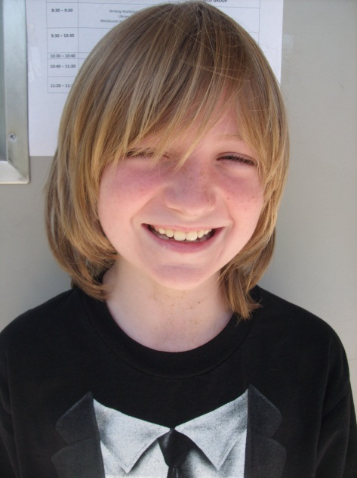

The Robbery of Mr. Barney
By: Tristan D.

Today, bully BOB robbed a dumb cow named Mr. Barney. Mr. Barney called the Secrecy Secret Cops of Secrets. When the Secrecy Secret Cops of Secrets arrived, they were being followed by bully BOBs men.

They had a huge boring argument. Mr. Barney knew that bully BOB robbed him he just figured out that bully BOB did not it was acutely doctor pig!!!

DA! DA! DA! Then doctor pig magically appeared out of nowhere the Secrecy Secret Cops of Secrecy arrested doctor pig. But it was actually doctor cow. He is a gangster. Doctor cow pulled a tommy gun and said, “Moo moo” (which means you’re doomed.) Mr. Barney ran into the house and called the super real police. They arrested doctor cow.

THE END

